Taylor Stapus

01/21/2025

CS 330

Module 2 / Resubmit

Milestone One: Project Proposal

For this project I used the feedback given to me from my original submission and decided to pick an area in my house that I believe would be possible to translate into an OpenGL environment. Below includes a picture of my reading nook in my house. The image includes a bookshelf with decorations, an ottoman with pillows, a picture on the wall and a rug on the ground.

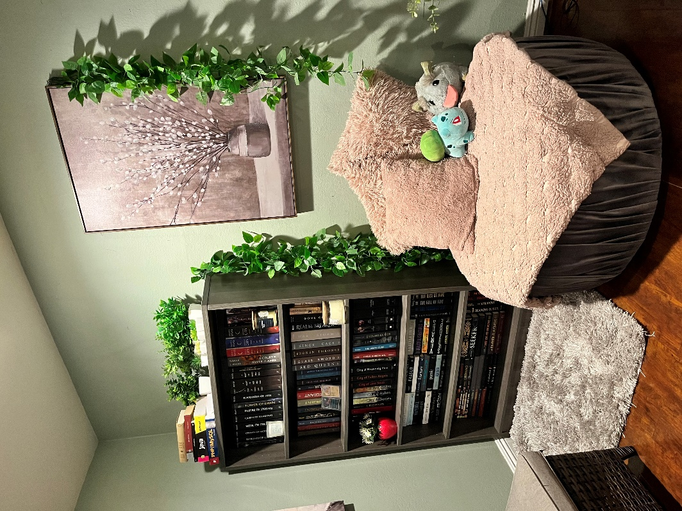

While looking at this picture, I found that I would have a fun time recreating this corner of my room. I would use planes to create the walls and the floor. The picture frame can be made from a transformed box and based on the references given to us, I can add a source picture as a plane to create the drawing that I have on the wall. The rug could also a box that I texturize.

Moving onto the ottoman. That would be created from a cylinder and the pillows on top would be boxes as well. The bookshelf itself can be a box, but I would simplify by maybe creating only a single shelf. I could still decorate the bookshelf with books made of boxes and candles made from cylinder, but I still need to add more complex shapes.

To do that I am going to focus on creating the little strawberry pot that I have on the bookshelf. I would accomplish that by using a rotated tapered cylinder as that base and I could add a stack of inverted pyramids to represent to plant inside the pot. I am still unsure how I am going to create the plant part so I might experiment with the different shapes, like a cone or a prism, until I can accomplish a desired effect.

This little corner does have a lot going on, so I might simplify it by only working on the bookshelf with decorations and the ottoman. But my goal will be to add the picture and the rug to finish the entire scene.